**TUGAS PERTAMA  
MATA KULIAH DATABASE MANAGEMENT SYSTEM**

|  |  |  |
| --- | --- | --- |
| OLEH :   |  |  | | --- | --- | | **MUHAMMAD DIENULLOH ULIL A.** | **L200164018** |   FAKULTAS KOMUNIKASI DAN INFORMATIKA  UNIVERSITAS MUHAMMADIYAH SURAKARTA  2018 |

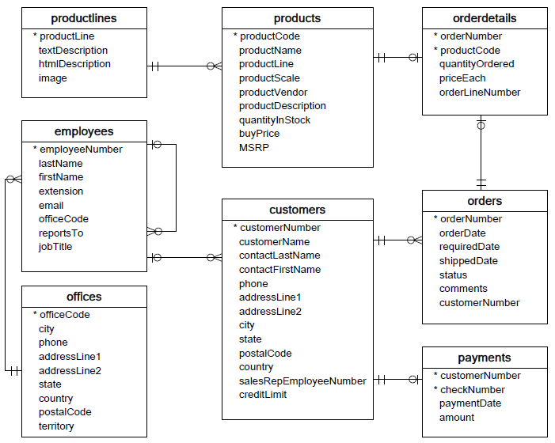**A.** **Table Relation Of Classic Models**

**B. Relation for Every Table**

1. Productlines to Product   
a. The relation is one to many  
b. A product only have one produclines  
c. A productlines probably have more than one product

2. Products to Orders  
a. The relation is many to many because their primary key is located on new tables asorderdetails  
b. A product could have order many times  
c. An order could contain of many product

3. Customers to Orders  
a. The relation is one to many  
b. A customers can make multiple order  
c. An order specific only can made by customers in one time

4. Employees to Customers  
a. The relation is one to many  
b. A employee could give service to many customers  
c. A customers only could serve by one customers at the time

5. Customers to payments  
a. The relation is one to many  
b. A customers can make many payments  
c. A payments only can make by the customers one time at same time

6. Office to Employees  
a. The relation is one to many  
b. An office can fills by many employees  
c. An employees only have job on one office

7. Employees to employees  
a. The relation is one to many  
b. Suppose there are employees that position as manager they can handle much of employees  
c. But an employees only can be handle by one manager